**Páginas consultadas**

* <https://www.youtube.com/watch?v=JDU3AzH3WKg&list=PLqnslRFeH2Upcrywf-u2etjdxxkL8nl7E&index=3>
* Sigmon function

<https://deepai.org/machine-learning-glossary-and-terms/sigmoid-function>

**Apuntes importantes**

* **Sigmoid function**

A Sigmoid function is a mathematical function which has a characteristic S-shaped curve.

*sigmoid function* is normally used to refer specifically to the logistic function, also called the logistic sigmoid function.

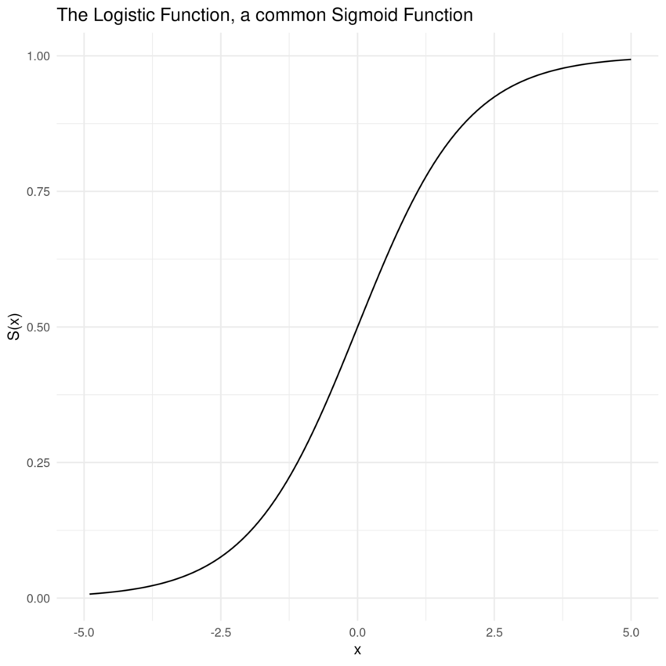

* Sigmoid functions are also useful for many machine learning applications where a real number needs to be converted to a probability.
* All sigmoid functions are monotonic and have a bell-shaped first derivative. There are several sigmoid functions and some of the best-known are presented below.

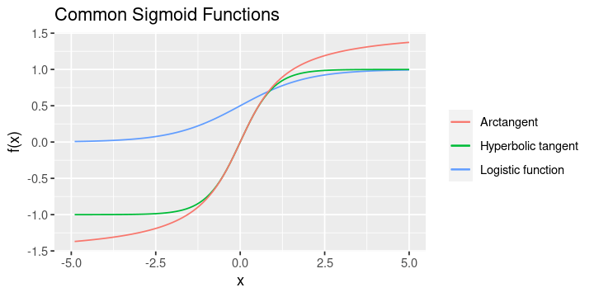

* Monotonic

In [calculus](https://en.wikipedia.org/wiki/Calculus), a function f defined on a [subset](https://en.wikipedia.org/wiki/Subset) of the [real numbers](https://en.wikipedia.org/wiki/Real_numbers) with real values is called **monotonic** if and only if it is either entirely non-increasing, or entirely non-decreasing

